Course: EE590 Project Report
Name: Cayde Xu
Student ID: 4617530704
Email: yongweix@usc.edu
Term: Fall 2025
Project Title: The Missing Piece: How convertible bond Reshape Classic Portfolio Models
Date: 12/11/2025

Executive Summary

This report examines whether incorporating convertible bonds into a traditional Capital Asset Pricing Model (CAPM) based equity portfolio can improve performance. The fundamental problem is that convertible bonds, which are hybrid securities, do not behave consistently like equities or bonds, and it is unclear whether their theoretical mix of upside participation and downside protection translates into measurable portfolio benefits. My analysis evaluates whether convertible bonds improve risk-adjusted returns, reduce volatility, or provide meaningful diversification in practice.

To address this problem, I implement a systematic empirical framework. I begin by evaluating SPY¹ as the market benchmark, computing its excess returns and establishing it as the baseline CAPM portfolio. Then I incorporate a diversified convertible-bond Exchange-Traded Fund (ETF) (with stock ticker CWB)², compute its excess returns, and decompose them into equity-like and bond-like components using a CAPM regression. Finally, I combine each CWB component with SPY to assess how much of a convertible bond’s behavior contributes to portfolio performance. To make the analysis more practical and representative of real convertible bond investment decisions, I extend the same procedure to two individual issuers, Tesla (TSLA) and Fortive (FTV). For each company, I reconstruct a return series for its convertible bond by using the official conversion terms and coupon information from issuer filings, estimate the credit-adjusted discount rate myself, and then decompose the bond into its equity-linked and bond-floor components to evaluate how each part interacts with SPY.

The results show clear patterns. In stable macroeconomic environments (2010–2021), convertible bonds provide modest diversification benefits: portfolios combining SPY with CWB or its components exhibit lower volatility while maintaining similar expected returns. However, in the stressed credit regime of 2022–2024, characterized by rising interest rates and widening credit spreads, these benefits disappear. CWB and its decomposed components underperform sharply, causing optimized portfolios to yield negative Sharpe ratios despite SPY remaining positive. The deterioration is driven by the bond-floor exposure, which is sensitive to credit risk and discount-rate increases.

The issuer-level results reinforce this conclusion. Tesla’s strong equity performance enables its convertible bond to deliver attractive risk-adjusted results: both the equity-like component and the full CB proxy significantly improve Sharpe ratios relative to SPY alone while maintaining lower volatility, meaning that investors could have gained upside exposure even without knowing in advance that Tesla would become a high-growth firm. In contrast, Fortive demonstrates the opposite pattern. Its moderate stock performance results in a convertible bond that behaves primarily like a low-yield corporate bond. The mean-variance optimizer assigns it almost zero weight, and portfolios constructed with Fortive’s CB or its components show no meaningful improvement in return, volatility, or Sharpe ratio.

The findings indicate that convertible bonds should not be incorporated indiscriminately. Their contribution to expected return is strongly regime-dependent: they enhance performance in calm credit markets or when the issuer’s equity performs well, but can become a drag during stressed macroeconomic conditions, where credit risk dominates and the mean return of the position deteriorates. Accordingly, convertible bonds require selective and conditional use rather than continuous inclusion.

By contrast, their effect on portfolio volatility is far more consistent. Regardless of macroeconomic regime, the structural features of convertible bonds tend to reduce variance, and the mean–variance optimizer responds by shifting allocations away from the instrument when its bond floor weakens. This interaction creates a complementary mechanism in which convertible bonds contribute stability and the optimizer prevents excessive downside, producing a resilient and balanced portfolio across a wide range of conditions, even if the improvement in mean return is not always guaranteed.

1. Introduction

The mean–variance investment strategy has long been one of the most influential frameworks in modern finance. It offers a clear way to balance risk and return by comparing expected excess returns to portfolio volatility and by emphasizing the role of correlations among assets. Even when individual securities are highly volatile, a well-diversified portfolio can achieve lower overall risk. Through the notion of the efficient frontier, the Markowitz framework³ provides investors with a menu of “optimal” portfolios for different risk levels. However, this approach has a critical practical weakness: it is extremely sensitive to input data. Because market data (such as stock returns and trading volumes) is itself noisy and unstable, small changes in estimates can lead to large swings in optimal weights, making the strategy difficult to implement reliably in real time.

Convertible bonds offer a potential remedy, especially for newer or growth-oriented firms that increasingly use them as a financing tool. As hybrid securities, they embed the flexibility to switch between debt-like and equity-like payoffs: investors can remain in the bond if conditions are poor or convert into equity when the issuer performs well. In principle, this structure combines downside protection from the bond floor with upside potential from the conversion option. Yet these advantages come with substantial frictions. Convertible bonds are notoriously difficult to price; their value depends on credit spreads, equity volatility, and changing conversion terms. Their coupons are usually lower than those of comparable straight bonds, so their pure fixed-income payoff can be weak if the equity option never finishes in the money. As a result, despite their intuitive appeal, convertible bonds are rarely incorporated explicitly into mean–variance or CAPM-based portfolio construction.

Given that both the Markowitz framework and convertible bonds possess distinct strengths and weaknesses, it is natural to ask whether they can be combined in a way that offsets their respective shortcomings. Because a convertible bond effectively embeds two asset exposures at once (a bond floor and an equity option) its payoff is determined by whichever component is more favorable at a given time. This built-in ability to switch between debt-like and equity-like states reduces the need for the optimizer to continually add new assets or aggressively reweight the portfolio in response to updated data, thereby dampening the impact of estimation noise and mitigating the instability of mean–variance allocations. This motivates the central question of this study: can convertible bonds, when evaluated through CAPM and integrated into a Markowitz-style portfolio, indeed improve risk–return trade-offs and make the strategy more robust in practice?

To investigate this question, I construct an empirical framework that integrates several complementary methods. I begin by applying CAPM regression and beta (beta is a parameter measuring how much a stock moves relative to the overall market) decomposition to SPY to establish its role as the baseline market portfolio. I then compute excess returns for CWB and separate its behavior into equity-like and bond-like components using CAPM-based factor decomposition. For issuer-level analysis, I retrieve official conversion terms, coupon schedules, and credit provisions from filings to compute each bond’s intrinsic value and credit-adjusted discount rate, enabling a parallel decomposition into equity-linked and bond-floor exposures. All computations are implemented after I construct reusable Python functions that repeatedly estimate optimal portfolio weights and evaluate mean returns, variances, Sharpe ratios, and t-statistics across different asset combinations. Finally, I employ comparative portfolio construction to integrate each component, both ETF-level and issuer level, into the SPY framework, assessing how the equity and bond segments of convertible bonds affect overall mean–variance behavior.

The empirical results show that, in all my portfolio configurations, adding convertible-bond exposure reduces portfolio variance, but its effect on expected excess return is far less stable. The CAPM structure remains broadly informative: equity-like and bond-like components load differently on market risk and influence the portfolio in distinct ways. In some environments, the bond component of the convertible bond behaves as intended and contributes to downside mitigation; in others, especially when credit conditions deteriorate, it becomes a drag on performance and offsets the benefits of the equity optionality. Overall, the findings suggest that combining convertible bonds with a CAPM-based mean–variance framework is not a guaranteed way to boost returns, but rather a conditional and informative extension of the theory that can improve risk characteristics and provide a useful reference for portfolio construction, while occasionally revealing that the bond leg of the structure can turn into a liability rather than a pure hedge.

2. Problem Statement

In this research, I address a set of practical and interconnected problems surrounding the role of convertible bonds in portfolio construction. Rather than treating convertible bonds as a theoretical asset class, my objective is to evaluate how they behave empirically within a CAPM and mean–variance framework and to determine whether they can provide meaningful benefits in real investment settings.

The first problem I consider is establishing a reliable baseline. Before analyzing convertible bonds, I evaluate the performance of SPY, the representative market portfolio, by examining its excess returns, volatility, and Sharpe ratio. This step serves two purposes: it verifies whether SPY behaves consistently with CAPM predictions and provides a benchmark against which any convertible-bond strategy must be compared. Only after confirming this foundation, I can meaningfully assess the incremental value of introducing hybrid instruments into the portfolio.

The second problem involves understanding the behavior of the CWB convertible bond ETF. I apply the same analysis used for SPY to examine whether CWB exhibits statistically significant returns and whether its characteristics justify considering it within a portfolio. Since convertible bonds combine equity sensitivity with bond-like stability, I further decompose CWB into an equity-like component and a bond-like component through CAPM regression residuals. This decomposition raises a key question: do the reconstructed components accurately replicate the behavior of the original convertible-bond ETF? Answering this validates whether my analytical framework properly captures the economic structure of convertible bonds.

A third problem concerns the practical interpretation of this decomposition. The goal of separating equity-like and bond-like exposures is to mimic the real decisions of an investor who holds multiple convertible bonds: at each moment, the investor can decide whether to keep the instrument as a bond or convert into equity. As the mean–variance model is well known for being highly sensitive to new data and prone to producing large and abrupt weight adjustments, my objective is to examine whether incorporating convertible bonds can mitigate this inherent instability. By simulating the two possible states of a convertible bond, either retaining it as a bond or converting it into equity, I aim to assess whether their inclusion can smooth these fluctuations and create a more stable portfolio.

However, reducing instability alone is not meaningful unless it leads to real economic improvements. Therefore, a central part of my analysis is to determine whether this reduction in variance translates into measurable benefits in portfolio performance, such as higher expected returns, lower overall risk, or improved risk-adjusted outcomes. In other words, I seek to verify whether stabilizing the mean–variance portfolio through convertible bonds produces tangible value, rather than merely reducing weight oscillations without offering practical gains.

Fourth, I evaluate the effect of conversion decisions on an existing portfolio. I test whether converting the equity-like component adds value to the original SPY portfolio and whether retaining the bond-like component provides stability without sacrificing performance. On the other hand, I split the dataset into a training period and a testing period. This distinction allows me to examine whether the observed benefits of convertible bonds persist across regimes or whether they deteriorate under stress. Without this separation, analyzing all years together would risk masking structural breaks and introducing bias into the results.

Finally, I consider the real-world applicability of these results. My earlier steps simulate holding many convertible bonds in a generalized portfolio without purchasing any specific issuer’s bond. However, in practice, investors purchase a particular convertible bond issued by a specific company. This introduces new complexities: conversion prices may adjust over time; issuer fundamentals may shift. To address this, I extend the analysis to real corporate examples, examining whether a single company’s convertible bond would have provided meaningful upside or downside protection had an investor held it.

By addressing these problems collectively, my goal is to determine whether combining convertible bonds with the mean–variance strategy can enhance portfolio stability, improve risk-adjusted returns, and reduce downside risk, both in theory and under actual market conditions.

2. Approach

First, to begin my analysis, I construct a clean and consistent dataset for SPY (2010 - 2021). I retrieve monthly price data from Yahoo Finance and compute returns using the percentage change between consecutive adjusted closing prices. This ensures that dividends and stock splits are properly incorporated into return measurements. I then merge the SPY return series with the monthly risk-free rate extracted from the Fama–French data library⁴ so that excess returns can be computed accurately. All datasets are aligned by date, converted to monthly frequency, and cleaned to remove missing observations, producing a stable time series suitable for regression analysis and portfolio construction.

To evaluate SPY as a valid benchmark and to establish a consistent modeling framework, I apply the Capital Asset Pricing Model (CAPM), originally developed by Sharpe (1964). The CAPM specifies that an asset’s excess return is linearly related to the excess return of the market portfolio:⁵
$$R_{i}-R_{f}=α_{i}+β_{i}\left(R_{M}-R_{f}\right)+ε_{i}$$
Here, $R_{i} - R_{f}$represent the excess return for asset, $β_{i}$ measures the asset’s exposure to market risk, $α_{i}$ captures abnormal performance, and $ε_{i}$ represents idiosyncratic noise.

To operationalize this model, I run an OLS regression using Python’s statsmodels package, with SPY’s monthly excess return as the dependent variable and the Fama–French “Mkt-RF” (Market return - risk free return) as the independent variable. The estimation produces $\hat{β}$= 0.9687 and $\hat{α}$= 0.0002, where $\hat{β}$ is extremely significant (t ≈ 79). The R² of the regression is 0.978, meaning that market movements explain almost all variation in SPY’s excess return.

These results empirically confirm that SPY behaves exactly as the CAPM predicts, with a market beta very close to 1 and an abnormal return that is essentially zero. Therefore, validate my decision to treat SPY as the baseline market portfolio for all subsequent convertible-bond analyses.

Second, I incorporate the iShares Convertible Bond ETF (CWB) to study how convertible bonds interact with the market portfolio. CWB is chosen because it is the most liquid and diversified U.S. convertible-bond ETF, making it an effective proxy for the overall convertible-bond market. I extract monthly adjusted prices from Yahoo Finance, compute monthly returns, convert them into excess return, and align them with SPY on the same monthly dates.

To assess whether CWB contributes meaningfully to portfolio construction, I compute its annualized excess return, volatility, Sharpe ratio⁶, and t-statistic using a Python function I constructed. Notice the Sharpe ratio measuring risk-adjusted performance as the ratio of annualized excess return ($E\left[R_{p}\right] - R_{f}$) to annualized volatility ($σ_{p}$), defined as
$\text{Sharpe Ratio}=\frac{E\left[R_{p}\right]-R_{f}}{σ_{p}}$
Applying this procedure, I obtain the following results:
Table 1. Summary Statistics for SPY (Monthly Data, Values in Percentages)
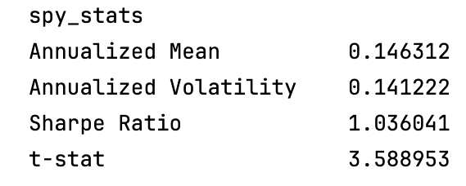
Table 2. Summary Statistics for CWB (Monthly Data, Values in Percentages)
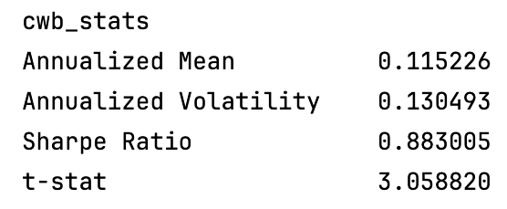
These findings indicate that, during the sample period, CWB generated lower risk and slightly lower excess return than SPY, producing a positive but modestly lower Sharpe ratio. Its statistically significant t-statistic shows that CWB delivered economically meaningful performance on its own. In addition, the CAPM regression for CWB yields a beta of 0.7657, indicating weaker linkage to broad equity-market movements and suggesting that convertible bonds offer diversification benefits within a portfolio.

Third, to evaluate the internal structure of convertible-bond returns, I decompose CWB into equity-like and bond-like components using CAPM regression as in equation (4):

$$r_{CWB}-r_{f}=α+β\left(r_{m}-r_{f}\right)+ϵ.$$

In practice, I first estimate $α$ and $β$ for CWB using an OLS regression in Python (statsmodels) with CWB’s excess return as the dependent variable and the market excess return as the regressor. Based on the estimated $β$, I construct the equity-like excess-return series $r_{t}^{eq,ex}=β\left(r_{m,t}-r_{f,t}\right),$which represents the portion of the convertible bond’s payoff that covaries with the market and reflects the value of its embedded conversion option. I then construct the bond-like excess-return series using the regression residual, $r_{t}^{bond,ex}=α+ϵ_{t},$ which corresponds to the bond floor and represents the payoff an investor would retain if the instrument were held purely as debt rather than converted. These two constructed series forms separate monthly excess-return time series that I subsequently treat as standalone assets within the mean–variance and Sharpe-ratio analysis.

This decomposition is economically reasonable because a convertible bond is, in essence, a corporate bond plus a call option. The regression cleanly separates these two exposures: $β$ captures the option-driven equity sensitivity, while $α$ and $ϵ$ capture the fixed-income and idiosyncratic credit components.

Fourth, my research focuses on the Markowitz strategy, which provides a framework for analyzing the trade-off between risk and return. As shown in the figure 1⁷ below, each asset has its own level of risk and expected return, which can be illustrated by plotting risk on the x-axis and return on the y-axis. When two risky assets are combined, adjusting their portfolio weights generates different risk–return outcomes. These outcomes form a curve known as the efficient frontier, which represents the set of portfolios that deliver the highest expected return for each level of risk. By further introducing a risk-free asset, the efficient frontier extends into a straight line known as the capital market line, which identifies the mean–variance portfolio that maximizes returns for any given level of risk.
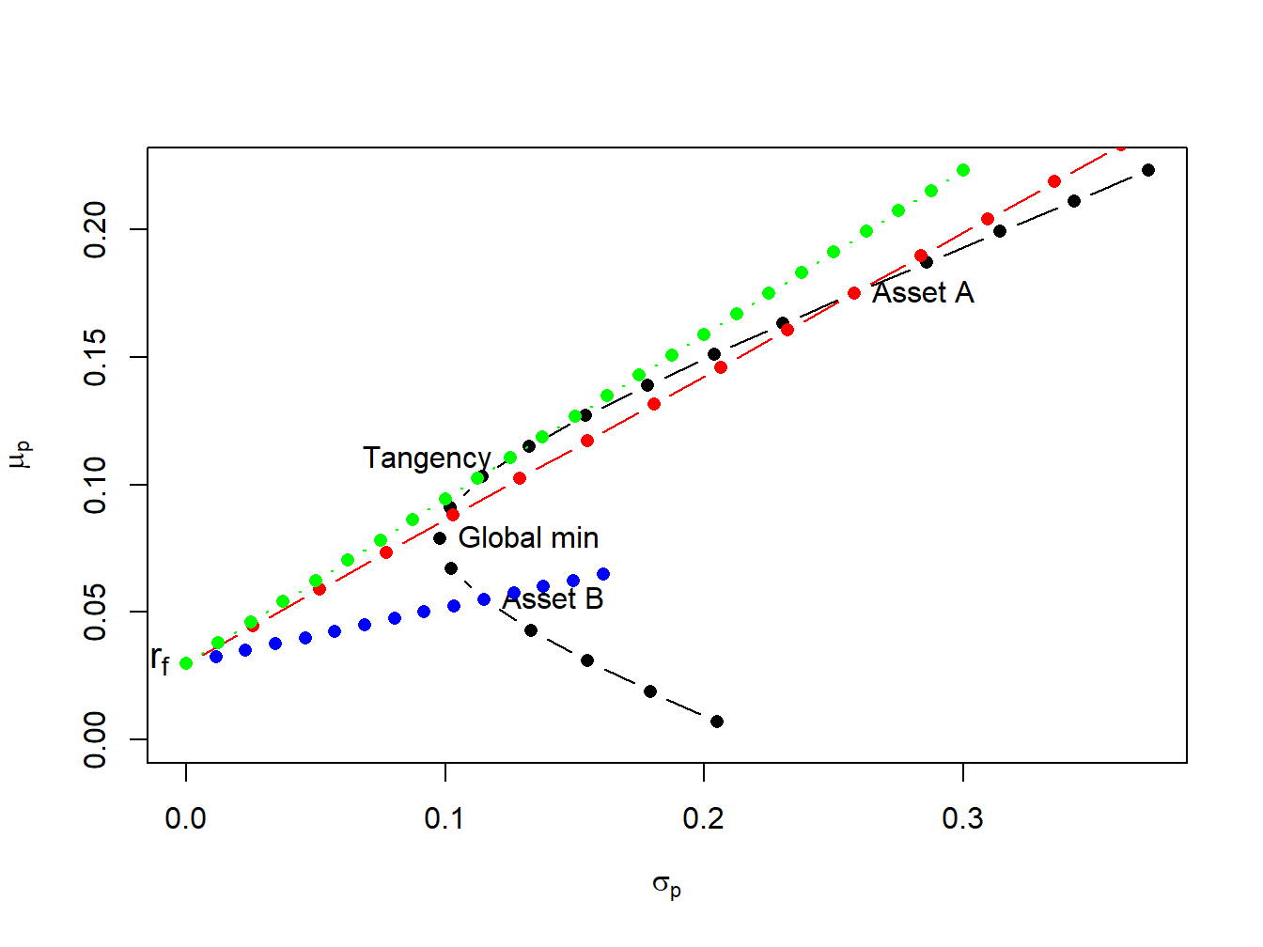
Figure 1. Efficient portfolios of two risky assets and Treasure-bills
Black dots represent portfolios of assets A and B; blue dots represent portfolios of T-bills and asset B; red dots represent portfolios of T-bills and asset A; green dots represent portfolios of the tangency portfolio and T-bills.

Having established this framework, I proceed to construct portfolios that incorporate SPY together with the convertible-bond components. The key step is determining the optimal portfolio weights. In the mean–variance setting, I implement the tangency-portfolio formula following the classic derivation of Markowitz (1952) and Sharpe (1964)³ ($w^{*}$ represent optimal weight for asset in portfolio) in Python using
$$w^{*}=\frac{Σ^{-1}μ}{1^{⊤}Σ^{-1}μ}$$
where $μ$ is the vector of expected excess returns and $Σ$ is the covariance matrix of those returns. I coded this computation as a reusable Python function that takes excess-return series as inputs and outputs the normalized maximum-Sharpe weights.

Using function, I compute tangency weights for three portfolio configurations:
1. SPY combined with the full CWB excess-return series,
2. SPY combined with the CWB equity-like excess-return series,
3. SPY combined with the CWB bond-like excess-return series.

With the output weights (e.g. 0.938659 on SPY excess and 0.061341 on CWB excess in the SPY + full CWB configuration), I construct the corresponding portfolio return series and evaluate their performance relative to SPY. All three portfolios deliver results extremely close to SPY alone, with small but consistent improvements in volatility and Sharpe ratio. SPY itself produces an annualized excess return of 0.1463, volatility of 0.1412, and a Sharpe ratio of 1.0360.

The SPY + full CWB portfolio reduces volatility to 0.1393 and achieves a slightly higher Sharpe ratio of 1.03656. The SPY + equity-like portfolio further lowers volatility to 0.1322 and attains the highest Sharpe ratio, 1.03669. The bond-like portfolio also modestly reduces volatility to 0.1346 while maintaining a Sharpe ratio of 1.03635, again marginally above the SPY benchmark.

Although these improvements are numerically modest, every configuration of CWB exposure produces a marginal enhancement in risk-adjusted performance, driven almost entirely by reduced volatility rather than higher expected return. These findings suggest that, during this sample period, convertible-bond exposures, whether full, equity-like, or bond-like, provided incremental diversification benefits without significantly altering expected returns.

Fifth, to test whether the portfolio improvements observed in the training data set (2010–2021) remain stable in test data set (2022 – 2024), I apply the same tangency-weight optimization and mean-variance strategy with convertible bond proxy to the 2022–2024 period. The results diverge sharply from the earlier decade.

Using the same strategy and function, all three portfolios, including SPY combined with the full CWB excess return, the equity-like component, and the bond-like component, perform dramatically worse in the test period compared with SPY alone.
Table 3. Summary Statistics for SPY (Test Period, Values in Percentages)
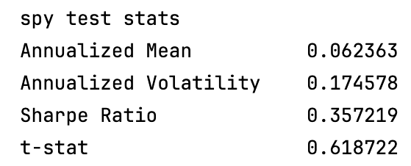
Table 4. Summary Statistics for SPY + Full CWB Portfolio (Test Period, Values in Percentages) 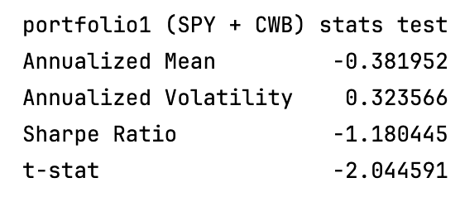
Table 5. Summary Statistics for SPY + CWB Equity Component (Test Period, Values in Percentages)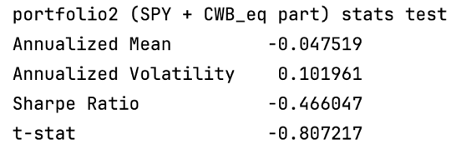
Table 6. Summary Statistics for SPY + CWB Bond Component (Test Period, Values in Percentages)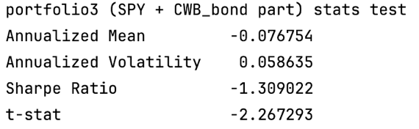
SPY maintains a modestly positive annualized excess return of 0.062 and a Sharpe ratio of 0.357, indicating resilience despite market volatility. In contrast, the SPY + full-CWB portfolio produces an annualized excess return of –0.382 with volatility of 0.324, resulting in a sharply negative Sharpe ratio of –1.18. The equity-like combination also performs poorly, yielding an annualized excess return of –0.0475 and a Sharpe ratio of –0.46. Even the bond-like component, which exhibits the lowest volatility among the three portfolios, still generates an annualized excess return of –0.077 and produces the most negative Sharpe ratio at –1.39.

Across all configurations, the deterioration is clear: every CWB-based strategy produces negative returns with substantially worse risk-adjusted performance than SPY, demonstrating that convertible-bond exposures failed to provide stability during the test period and instead amplified losses.

This deterioration is consistent with well-documented macroeconomic events: the fastest Federal Reserve rate-hike cycle since the 1980s, widening credit spreads, and sharp declines in corporate-bond valuations. According to the Federal Reserve’s published policy actions, the target federal funds rate rose from 0–0.25% in early 2022 to 5.25–5.50% by mid-2023, representing the sharpest tightening cycle in more than four decades.⁸ During the same period, corporate-bond yields tracked by the ICE BofA US Corporate Index widened by more than 150 basis points, and convertible-bond indices such as the ICE BofA All-US Convertibles Index recorded significant drawdowns.⁹

Since convertible bonds are fundamentally corporate bonds with embedded call options, their bond floors are highly sensitive to credit-risk surprises and discount-rate increases. As these forces intensified in 2022–2024, especially around the post-COVID reopening period, bond-floor valuations deteriorated materially, and the equity-linked component did not provide enough upside to offset these losses. This dynamic directly reversed the stability benefits observed in the training period.

A direct comparison confirms this pattern. SPY remains modestly positive over 2022–2024, with an annualized excess return of 0.062 and a Sharpe ratio of 0.357, demonstrating resilience despite market volatility. In contrast, CWB delivers an annualized excess return of –0.028 and a Sharpe ratio of –0.207, with a negative t-statistic, making clear that its underperformance does not stem from equity-market weakness but from stresses specific to convertible bonds.

Sixth, a striking reversal emerges when I impose the long-only constraint on the tangency-portfolio optimization. As shown in the results, all three CWB-based portfolios (SPY combined with the full CWB excess return, the equity-like component, and the bond-like component) converge to the same long-only tangency weights. Specifically, the optimizer assigns a weight of 1.0 to SPY and a weight of 0.0 to the CWB component.

This outcome is highly informative. It indicates that, once short selling is prohibited, the mean–variance optimizer immediately assigns zero weight to every convertible-bond component. In other words, before the convertible bond even has a chance to provide equity-option upside or bond-floor protection, the optimizer identifies that CWB’s risk-return profile is inferior to SPY during the test period. The model therefore protects the portfolio by excluding CWB entirely.

This reveals a “two-layer” protection mechanism:
1. First layer — Markowitz protection:
The mean–variance optimizer detects that all CWB components produce negative excess returns and negative Sharpe ratios in 2022–2024. As a result, it shifts the entire allocation to SPY, preventing the portfolio from being dragged down by CWB’s credit-driven losses.
2. Second layer — Convertible-bond structural protection:
Even without relying on the Markowitz optimizer, convertible bonds inherently cap downside through their bond floor. In benign environments (as in 2010–2020), this structural protection contributes to lower volatility and mild Sharpe-ratio improvements.

On the other hand, I want to move beyond constructing a convertible-bond proxy and instead evaluate a real, fully specified convertible bond in practice. To do this, I extend my approach to a firm-level case study based on Tesla’s 2014 convertible bond issuance. To ensure authenticity, I retrieve the original offering documents directly from the SEC’s EDGAR database¹⁰, which provide the official conversion ratio (CR = 2.7788), conversion price ($359.87), and coupon rate (0.25%). I also obtain Tesla’s long-term issuer credit rating during the issuance period (BB / Ba3 range)¹¹, which I use to estimate a market-consistent discount rate by adding the historical BB credit spread to the Treasury yield curve.¹² This allows me to construct a realistic proxy for the bond floor.

To model the economic value of the convertible bond, I compute: Conversion value $CV_{t}=CR×S_{t}$, where $S_{t}$ is Tesla’s monthly stock price. This represents the equity-linked payoff if the investor chose to convert. Bond-floor value $BF_{t}=\sum_{k=1}^{n}{\frac{c/12}{{\left(1+r\right)}^{k}}}+\frac{1000}{{\left(1+r\right)}^{n}}$, where c is the coupon (0.25%), and r is the discount rate estimated from credit spreads. This approximates the payoff if the investor keeps the bond unconverted.
Table 7. Mean–Variance Portfolio Results for SPY and TSLA Components (Values in Percentages)
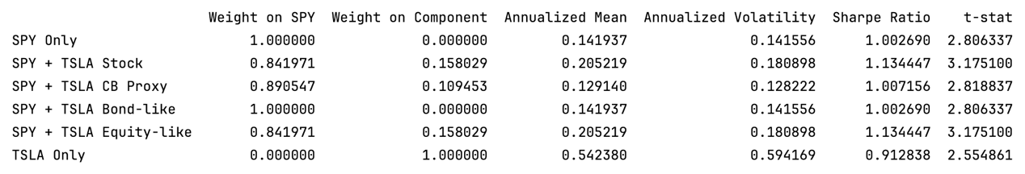
The Tesla case illustrates how convertible bonds behave when the issuing firm experiences strong equity appreciation. SPY alone delivers an annualized excess return of 0.142 with a Sharpe ratio of 1.003, serving as the baseline. When Tesla stock is introduced, the optimizer assigns a 15.8% weight, increasing the annualized return to 0.205 with a Sharpe ratio of 1.134, which represents a clear improvement driven by Tesla’s high-growth trajectory. The equity-like component of the convertible bond performs almost identically, confirming that during this period the convertible bond’s payoff was dominated by its option-like sensitivity to Tesla’s rising stock price.

The full convertible-bond proxy receives a smaller allocation (10.9%) yet still improves the Sharpe ratio relative to SPY. This occurs because the proxy captures part of Tesla’s upside through its equity-linked exposure while simultaneously suppressing volatility via the bond floor. In other words, the convertible structure absorbs enough of Tesla’s appreciation to raise expected returns, but the bond component tempers price swings, giving this portfolio the lowest volatility (0.128) among all Tesla-inclusive configurations. This balance explains why the CB proxy offers a smoother, more stable risk profile: it retains convex exposure to strong equity performance but avoids the extreme fluctuations characteristic of Tesla’s stand-alone stock.

By contrast, the bond-like component receives zero weight in the tangency portfolio because its return is too low to compete with the market benchmark. And holding Tesla alone, while producing the highest raw return, generates much higher volatility, lowering its risk-adjusted performance relative to SPY-combined strategies.

Therefore, the Tesla results demonstrate that a convertible bond can generate attractive risk-adjusted performance even when the investor does not know beforehand whether the issuer will become a high-growth company or a weak performer. The structure allows the portfolio to retain meaningful upside participation while keeping volatility far below that of the underlying stock. This asymmetric payoff makes convertible bonds particularly valuable during periods of uncertainty, where missing a major growth opportunity and avoiding excessive downside risk are both critical concerns.

Finally, after completing the Tesla case, I repeat the same analytical structure for Fortive’s 0.875% Convertible Senior Notes due 2022, with one important modification: FTV’s conversion rate changed over time due to the 2020 Vontier spin-off.¹³
This requires a slightly different preprocessing step from the Tesla analysis：

1. Unlike the Tesla case, Fortive’s conversion rate is not fixed. According to the issuer’s SEC filings, the original conversion rate was 9.7804 shares per $1,000 face value, which increased to 10.5791 shares per $1,000 following the 2020 Vontier spin-off event. Using these time-varying conversion terms, I compute the monthly conversion value as $CV_{t}=CR_{t}×S_{t},$where $S_{t}$is Fortive’s monthly stock price. Month-to-month changes in this conversion value yield the equity-like excess-return series used in the portfolio analysis.

2. Constructing the bond-floor component
As with Tesla, I compute the bond floor using coupon (0.875%), maturity, and FTV’s corporate bond yields to discount future cash flows. Because FTV is an investment-grade industrial issuer, the discount rate is materially lower than Tesla’s, which produces a bond-floor series with extremely low volatility and near-zero return.

3. Portfolio construction
Using SPY as the baseline, I build the following portfolios exactly as before, result showing below.
Table 8. Mean–Variance Portfolio Results for SPY and FTV Components (Values in Percentages)
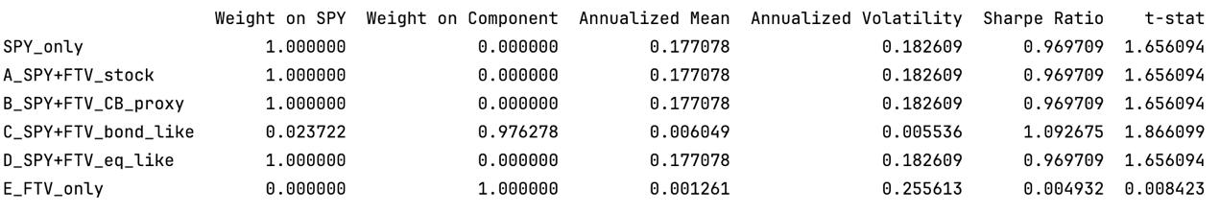

The Fortive results illustrate in detail how mean–variance optimization responds when the issuer exhibits only moderate growth. As shown in Table 8, all mixed portfolios (SPY combined with FTV stock, the FTV CB proxy, or the equity-like component) receive a 100% allocation to SPY, with the optimizer assigning 0% weight to every convertible-bond exposure. The only exception is the bond-like component, which receives a small 2.37% weight purely because its volatility is extremely low (0.0055). Across these portfolios, annualized means cluster tightly around 0.177, annualized volatility remains essentially unchanged at 0.1826, and the resulting t-statistics fall between 1.65 and 1.86, all below the conventional 1.96 5%-significance threshold. This implies that differences in mean excess returns across the FTV-based portfolios are not statistically meaningful, so the optimizer’s weight decisions carry the primary economic message.

That message is clear: poor-performing convertible-bond exposures are automatically eliminated by the mean–variance optimizer. In both the diversified CWB ETF and the issuer-specific Fortive case, when the underlying stock delivers weak or only moderate performance, the optimizer assigns zero weight to all convertible-bond exposures, including the full proxy, the equity-like portion, and even the bond-like portion in most configurations. This filtering mechanism prevents low-value or low-Sharpe assets from entering the portfolio and creates an automatic layer of downside protection by retaining only securities whose risk-adjusted returns improve upon SPY.

A closer look at the Fortive components highlights why this happens. The bond-like component achieves the lowest volatility in the entire analysis (0.0055) and a Sharpe ratio above one, but its annualized mean (0.0060) is extremely small, and its t-statistic (1.866) remains statistically indistinguishable from zero. Meanwhile, FTV equity alone carries much higher volatility (0.2556) but delivers an annualized mean close to zero (0.00126) with an even weaker t-statistic (0.0084). Collectively, these outcomes show that convertible bonds can substantially reduce variance via their bond floor, but they do not improve returns or statistical significance when issuer growth is modest. This is precisely why the optimizer assigns only a minimal 2.37% weight to the bond-like portion and zero to all other FTV-linked exposures.

This pattern holds consistently across all settings examined in the report: the diversified convertible-bond ETF (CWB), the high-growth issuer (Tesla), the moderate-growth issuer (Fortive), across equity-like and bond-like decompositions, and across both stable and stressed macro regimes. The overarching conclusion is that convertible-bond value emerges only when the issuer’s stock appreciates strongly; otherwise, the mean–variance framework correctly minimizes the exposure to zero, preventing underperforming convertible bonds from harming portfolio outcomes.

Conclusion

This report investigates whether convertible bonds can enhance portfolio performance within a CAPM and Markowitz mean–variance framework. Across a diversified ETF (CWB) and two firm-level cases (Tesla and Fortive), the results show that convertible bonds offer benefits only under specific conditions. In stable macroeconomic environments (2010–2021), they reduce portfolio volatility and slightly improve Sharpe ratios, primarily because the bond floor stabilizes returns while the equity-linked component participates in market gains. However, these improvements are modest and driven almost entirely by variance reduction rather than higher expected returns. When macroeconomic conditions deteriorate, as in the 2022–2024 period, convertible bonds perform poorly due to rising discount rates, widening credit spreads, and weakening corporate-bond valuations. During this stressed regime, every CWB-based portfolio underperforms SPY, producing negative excess returns and negative Sharpe ratios. These findings show that the downside “protection’’ of convertible bonds is conditional and does not hold under severe credit stress.

The issuer-level results reinforce this regime-dependent behavior. Tesla’s convertible bond, issued before its extraordinary equity appreciation, enhanced portfolio performance even without knowing beforehand that Tesla would become a high-growth firm. The convertible security captured substantial upside through its equity-linked component while maintaining much lower volatility than Tesla stock, demonstrating the value of convex equity participation combined with a bond floor. In contrast, Fortive’s moderate growth caused its convertible bond to behave like a low-yield corporate bond: volatility was extremely low, but returns were statistically indistinguishable from zero. In such cases, the mean–variance optimizer automatically assigns zero weight to the convertible-bond exposure and effectively filters out assets whose risk-adjusted performance does not exceed the market benchmark. This mechanism appears consistently across CWB, Tesla, and Fortive and illustrates that mean–variance optimization and the convertible-bond structure together provide a dual layer of downside protection because the optimizer excludes low-value exposures and the bond floor limits volatility.

Overall, while the initial expectation was that convertible bonds would directly improve mean–variance performance, the results show a more nuanced and mutually reinforcing relationship. When market volatility rises, the structural features of convertible bonds help reduce portfolio variance while still preserving part of the issuer’s upside. In contrast, when the convertible bond becomes vulnerable because its bond floor is affected by credit risk or rising discount rates, the mean–variance optimizer protects the portfolio by shifting the allocation away from the deteriorating instrument before losses occur. Taken together, these findings indicate that the combination of mean–variance optimization and convertible-bond structure functions as a balanced hybrid mechanism. Convertible bonds contribute stability during market turbulence and mean–variance optimization safeguards the portfolio when the bond component weakens. A portfolio that integrates both elements therefore offers a practical and resilient compromise across a wide range of economic conditions, though not necessarily the highest return one.

4. References

[1] Yahoo Finance. “CWB: iShares Convertible Bond ETF.” Accessed 2025.
https://finance.yahoo.com/quote/CWB/.

[2] Yahoo Finance. “SPY: SPDR S&P 500 ETF Trust.” Accessed 2025.
https://finance.yahoo.com/quote/SPY/.

[3] Markowitz, H. (1952). Portfolio Selection. The Journal of Finance, 7(1), 77–91

[4] Fama, Eugene F., and Kenneth R. French. “Fama/French 3 Factors [Monthly].”
Fama-French Data Library. Accessed 2025.
https://mba.tuck.dartmouth.edu/pages/faculty/ken.french/data_library.html

[5] Sharpe, William F. “Capital Asset Prices: A Theory of Market Equilibrium under Conditions of Risk.” Journal of Finance 19, no. 3 (1964): 425–442. https://www.jstor.org/stable/2977928

[6] Sharpe, William F. 1966. “Mutual Fund Performance.” Journal of Business 39 (1): 119–138. https://www.jstor.org/stable/2351741

[7] Zivot, E. (2023). Introduction to Computational Finance and Financial Econometrics with R (Figure 11.8). Retrieved from https://bookdown.org/compfinezbook/introcompfinr/

[8] Board of Governors of the Federal Reserve System. Federal Open Market Committee (FOMC) Statement Releases. 2022–2023. https://www.federalreserve.gov/monetarypolicy/fomccalendars.htm.

[9] ICE Data Indices. ICE BofA US Corporate Index and ICE BofA All-US Convertibles Index Data. 2022–2023. https://indices.theice.com.

[10] FRED. ICE BofA BB US High Yield Index Option-Adjusted Spread (BB OAS). https://fred.stlouisfed.org/series/BAMLH0A1HYBB.

[11] Moody’s Investors Service and S&P Global Ratings. Tesla Motors Credit Rating Reports. 2014.

[12] Tesla, Inc. Convertible Senior Notes Due 2019: Offering Documents. SEC EDGAR Filing, February 26, 2014. https://www.sec.gov/edgar/browse/?CIK=1318605.

[13] Fortive. “Notice to Holders re Conversion Rate Adjustment (Vontier).” SEC filing, October 23, 2020. https://investors.fortive.com/sec-filings/conversion-rate-adjustment.

6. Check List for Final Report: Check that you addressed each item and
THEN initial it.
1. Confirm that you read the guidelines sentence by sentence. Failure to
do so will lead to rejection of the report, getting no credit and retaking
EE590 the following semester. Yes you will still have to pay again
_____________CX_________________
2. Structure of document: fond, spaces, minimum number of required pages.
Font should be 11. Space should be single or 1.15. Margins should be 1 in all
around
________CX________________
3. All abbreviations are defined when first appeared ________CX______________
4. All figures and tables are labeled with numbers and captions. Figure
captions go under the plots and table captions above tables. Make sure you
indicate units. ________CX_______________
5. Figures, tables, diagrams, pictures taken from the web or papers should
include the source otherwise it is plagiarism. They cannot be used to fill
space ____________CX__________________
6. No text should be copied and paste from anywhere as it is plagiarism. If you
quote someone you should put it under “….” and identify the source as a
reference but it should not be more than a couple of lines._______CX______________
7. All listed references should be mentioned in text. Use format [1], [2]
_______________CX________________
8. Grammar and English should be carefully checked . No report with typos
and grammatical errors will be accepted. Check the tenses. Some students
tend to use parts of the proposal that uses the words ‘I will’ , ‘I plan’ etc. The
final report should state what you did not plan to do.
________CX_________________
9. All variables in equations should be defined and explained
________CX___________
PLIAGIARISM: Any identified form of plagiarism will be reported to the University and in
addition to receiving no credit for EE590 the graduation of the student may be affected. All
past reports are kept and a software program is used to identify overlaps with past reports and
literature. If you use figures or tables or diagrams from a website or papers you need to
indicate that and include the reference. Projects completed for other courses cannot be used
for EE590. All reports will be tested using a plagiarism software.
I confirm that my proposal/report abides with the above guidelines and no material was
copied from any source that is not indicated in the report and referenced accordingly.
Name
________________Cayde Xu________________________________
Signature____________Cayde Xu________________________________

Appendix
Software and Computational Environment
All empirical analyses were conducted using Python in a reproducible environment. The primary software components are summarized below:

Programming Language
Python 3.10.11

Computational interface
Jupiter Notebook & PyCharm

Core Libraries
Pandas, NumPy, Statsmodels, yfinance

Data Sources
SPY（S&P 500 ETF）
BlackRock iShares. (2025). SPDR S&P 500 ETF Trust (SPY): Historical price and return data. Retrieved from Yahoo Finance:
https://finance.yahoo.com/quote/SPY/

CWB（iShares Convertible Bond ETF）
BlackRock iShares. (2025). iShares Convertible Bond ETF (CWB): Historical price and return data. Retrieved from Yahoo Finance:
https://finance.yahoo.com/quote/CWB/

TSLA (Tesla, Inc.)
Tesla, Inc. (2025). TSLA: Historical equity prices. Retrieved from Yahoo Finance:
https://finance.yahoo.com/quote/TSLA/

FTV (Fortive Corporation)
Fortive Corporation. (2025). FTV: Historical equity prices. Retrieved from Yahoo Finance:
https://finance.yahoo.com/quote/FTV/

Fama–French 3 Factors (FF3)
Fama, E. F., & French, K. R. (2025). Fama/French 3-Factor Research Data (U.S.).
Retrieved from Kenneth R. French Data Library:
https://mba.tuck.dartmouth.edu/pages/faculty/ken.french/data_library.html

